Module 6 – Working with Filters in Tableau
6.1 Filters (Addition and Removal)
Filters in Tableau help you display only the required data from a dataset.
Why Filters are Used
- Focus on important data
- Remove Unnecessary Records
- Improve dashboard interaction
- Analyze specific categories, regions, dates, etc.

How to Add a Filter
Steps:
- Open Tableau worksheet
- Drag a field to the Filters Shelf
- Select required values
- Click OK
Example:
Filter only “Technology” category from Superstore data.

How to Remove a Filter
Steps:
- Locate filter on Filters Shelf
- Right-click the filter
- Select Remove

Ways of filtering-Filter shell, interactive filters, Header, Legends
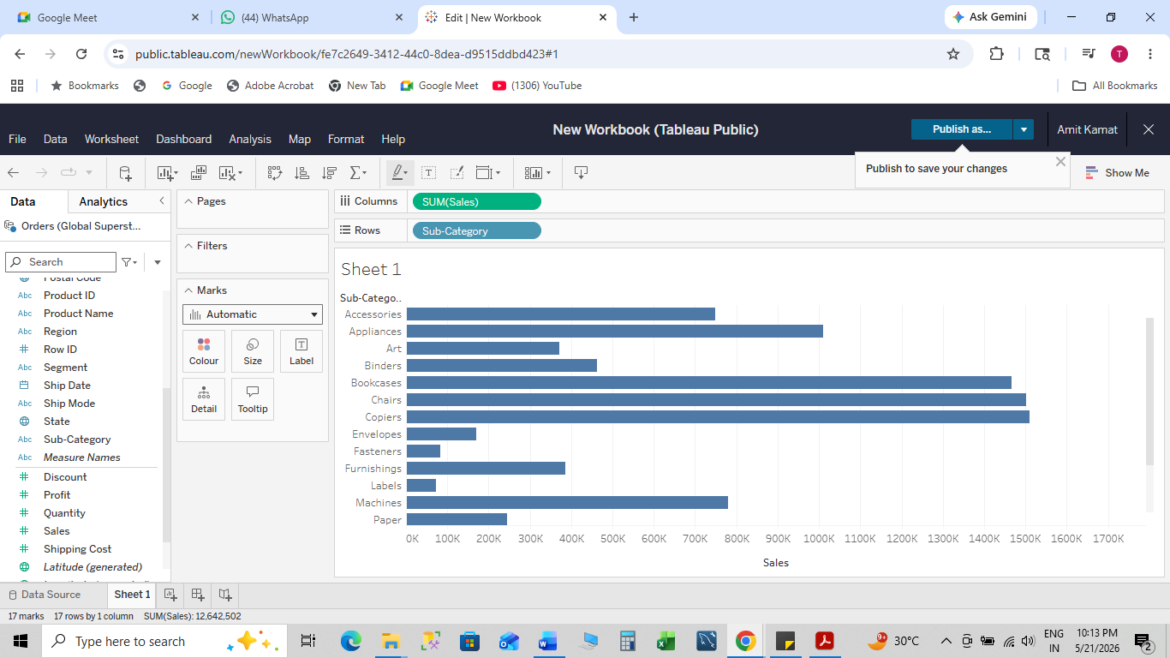

6.2 Filtering Continuous Dates, Dimensions, and Measures
A. Continuous Date Filter
Continuous dates show a timeline.
Example:
Filter sales between Jan 2023 and Dec 2023.
Steps:
- Drag Order Date to Filters
- Choose:
  - Relative Date
  - Range of Dates
- Click OK

B. Dimension Filter
Dimensions are categorical fields.
Examples:
- Region
- Category
- Segment
Steps:
- Drag dimension field to Filters
- Select values
- Click OK

C. Measure Filter
Measures are numerical values.
Examples:
- Sales
- Profit
- Quantity
Steps:
- Drag measure to Filters
- Select:
  - Sum
  - Average
  - Range
- Set values
- Click OK

Image – Date, Dimension, and Measure Filters

6.3 Filtering in Tableau
Filtering allows users to interactively analyze data.
Common Filtering Methods
- Filter Shelf
- Quick Filters
- Context Filters
- Data Source Filters
- Extract Filters

Show Filter Option
Steps:
- Right-click field in Filters Shelf
- Select Show Filter
- Filter card appears on right side
Users can now interactively select values.

Interactive Filter Example
6.4 Types of Filters in Tableau
Filter Type | Purpose
Extract Filter | Filters data before extract creation
Data Source Filter | Applies filter at data source level
Context Filter | Creates primary filtered dataset
Dimension Filter | Filters categorical data
Measure Filter | Filters numerical data
Table Calculation Filter | Filters calculated table results

Filter Hierarchy
- Extract Filter (Click Create Extract, Filters, Add, Number of Rows, Select State field, Click on the row containing State, Click Edit, Select only one state, California- Texas- New York, Click OK, Click OK again), than go to sheet1 and create
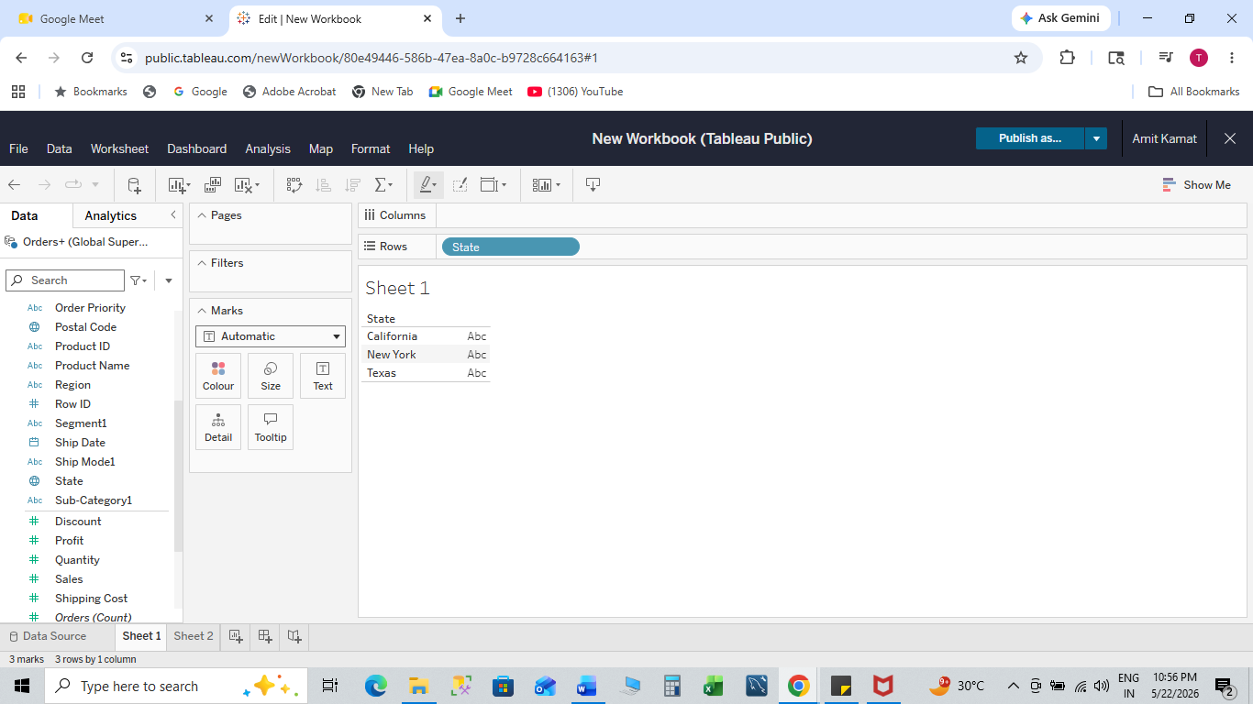
- Data Source Filter
- Context Filter
- Dimension Filter
- Measure Filter
- Table Calculation Filter
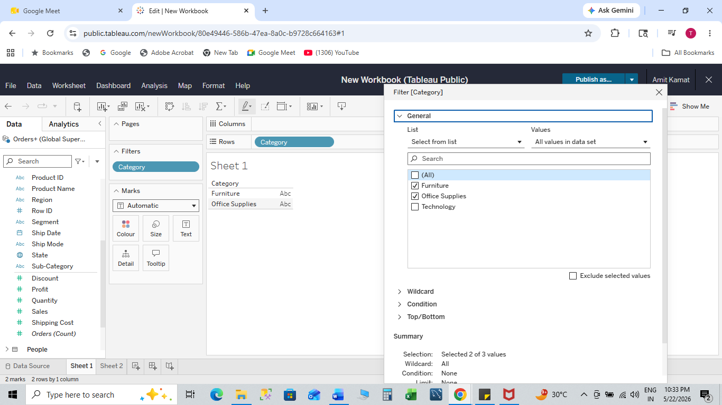
Data Source Filter
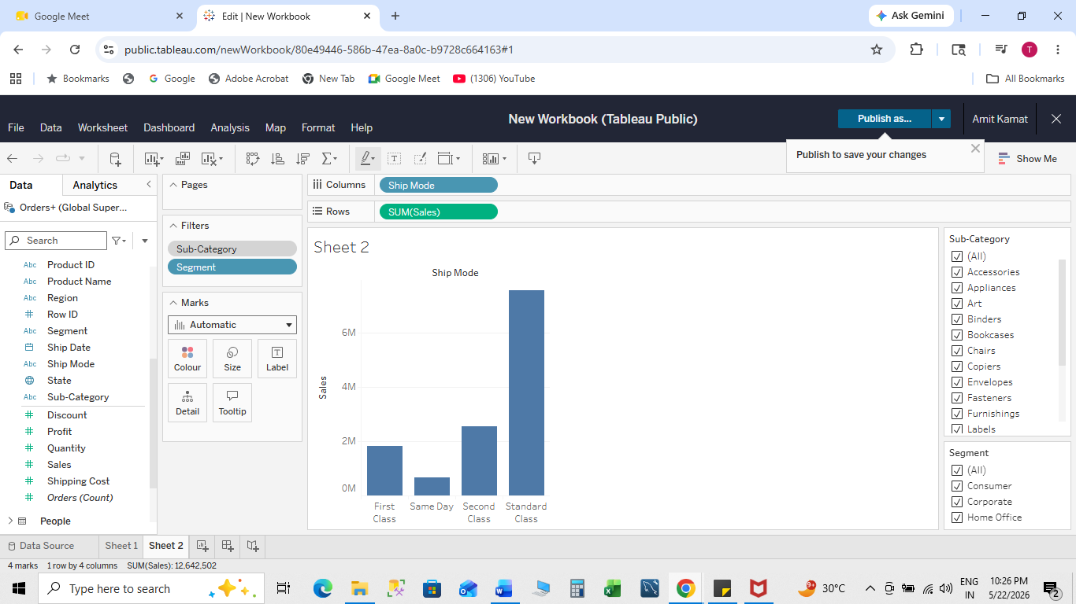
Context Filter

6.5 Filtering and Order of Operations
Order of operations defines how Tableau applies filters.
Important Concept
Not all filters work at the same stage.
Example:
If Context Filter is applied first, all other filters work on the filtered dataset.

Tableau Order of Operations Diagram

Hands-on Exercise
Exercise 1 – Add Filter Using Date/Dimension/Measure
Objective
Filter sales data using:
- Date
- Category
- Sales amount

Steps
Step 1 – Open Dataset
Use Global Superstore dataset.
Step 2 – Create Visualization
- Drag Category → Rows
- Drag Sales → Columns
Step 3 – Add Date Filter
- Drag Order Date → Filters
- Select Range of Dates
Step 4 – Add Dimension Filter
- Drag Region → Filters
- Select “East” and “West”
Step 5 – Add Measure Filter
- Drag Sales → Filters
- Choose SUM
- Set range above 10,000

Exercise 2 – Use Interactive Filter
Steps
- Right-click Region filter
- Click Show Filter
- Select regions interactively
- Observe chart changes

Exercise 3 – Customize/Remove Filters
Customize Filter
- Click drop-down on filter card
- Choose:
  - Single Value
  - Multiple Values
  - Dropdown
  - Slider
Remove Filter
- Right-click filter
- Select Remove

Example – Filter Customization

7

Important Interview Questions
- What is a filter in Tableau?
- Difference between Dimension and Measure filters?
- What is Context Filter?
- Explain Tableau Order of Operations.
- How do interactive filters work?

